Guest: Where there is no conflict between religion and science
The conflict between religion and science isn’t, writes guest columnist Michael Zimmerman
By Michael Zimmerman
Special to The Times 9 February 2014
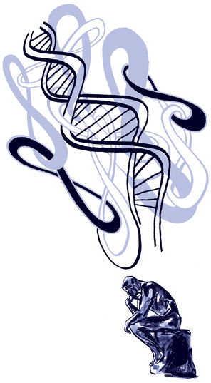
THE conflict between religion and science isn’t what most people think it is. Let me say that even more simply: the conflict between religion and science isn’t.
In actuality, it’s a manufactured controversy, promoted by some to generate support for their partisan interests and to fool people into believing that they have to choose between the two.
The battle, for the most part, has revolved around evolution.
But consider that more than 12,900 Christian clergy members in the country have signed a letter affirming that “the timeless truths of the Bible and the discoveries of modern science may comfortably coexist.”
They have also asserted that “the theory of evolution is a foundational scientific truth, one that has stood up to rigorous scrutiny and upon which much of human knowledge and achievement rests. To reject this truth or to treat it as ‘one theory among others’ is to deliberately embrace scientific ignorance and transmit such ignorance to our children.”
Hundreds of these religious leaders, along with their congregations, will be celebrating Evolution Weekend from Feb. 7-9. All of the congregations, 560 in 13 countries, are holding a local event to raise the quality of the dialogue about the relationship between religion and science.
It’s obvious that there’s a great need for the discourse to be improved. Two examples make this point clearly:
Republican U.S. Rep. Paul Broun running for the open U.S. Senate seat from Georgia has claimed, “All that stuff I was taught about evolution, embryology, the Big Bang Theory, all that is lies straight from the pit of hell.”
Last month, Albert Mohler, the president of the Southern Baptist Theological Seminary, proclaimed, “Evolution, as an ideological principle, is absolutely central to the liberal progressive project of replacing the Christian worldview and Christian morality with a different set of moral and cultural principles.”
Evolution is nothing of the sort. It is neither a lie “straight from the pit of hell” nor a part of a conspiracy to replace “the Christian worldview and Christian morality.” Indeed, if it were either of these things, why would so many Christian clergy members so aggressively promote evolution?
The Christian clergy members who believe evolution can coexist with theology, like most clergy of most religions, recognize that their sacred texts were not written as scientific treatises.
They are comfortable embracing the words of the Dalai Lama, which appear at the top of a letter signed by American Buddhist clergy members: “If scientific analysis were conclusively to demonstrate certain claims in Buddhism to be false, then we must accept the findings of science and abandon those claims or adopt them as metaphor.”
The clergy who will be leading Evolution Weekend events reject creationism in all of its guises — from biblical literalism, which leads to a belief in an Earth that is only about 10,000 years old, through so-called “creation science,” to intelligent design. These beliefs diminish and degrade religion while undermining the basic principles upon which science rests.
The most recent of creationism’s many incarnations, intelligent design, is particularly repugnant to many clergy members because they see it as a reprise of the 19th century idea of the “God of the gaps.”
Scottish evangelist Henry Drummond wrote in 1894, “There are reverent minds who ceaselessly scan the fields of Nature and the books of Science in search of gaps, gaps which they will fill up with God.” Theologians over the years believed that it made little sense to define religion in such a way that God’s role shrinks with every new scientific discovery.
Christian clergy members have joined with rabbis and imams, with Buddhist clerics and Unitarian Universalist ministers, to form The Clergy Letter Project, an organization designed to demonstrate that deeply held religious belief is not threatened by any aspect of modern science. Collectively, they recognize that the purpose of religion is not to convey scientific information but to transform hearts.
The actions and the language of the clergy celebrating Evolution Weekend and signing one of the Clergy Letters are not what many expect from religious leaders, but it is the face of modern religion.
The signatories to the letters come from all corners of the country, from some of our smallest parishes and from some of our great cathedrals. Some of them were recently ordained and some have been serving their congregations for over half a century. Some are liberal, some are conservative. Men and women, members of all races, are represented. These religious leaders are as diverse as are the people of the United States. As a group they share only two striking features: They have devoted their lives to their faith and they recognize the importance of evolution.
Evolution Weekend will be celebrated around the state and across the globe. Congregations from Seattle to the Philippines and from Richland to Chile will raise their voices to demonstrate that there need not be a conflict between religion and science. They will discuss the different methodology embraced by the two fields.
As the Christian clergy letter says, “We ask that science remain science and that religion remain religion, two very different, but complementary, forms of truth.”
Michael Zimmerman, an evolutionary biologist, is vice president for academic affairs at The Evergreen State College and executive director of The Clergy Letter Project.

