United Church of Christ

Science and religion at Darwin’s 200th birthday
Written by Staff Reports
February 11, 2009
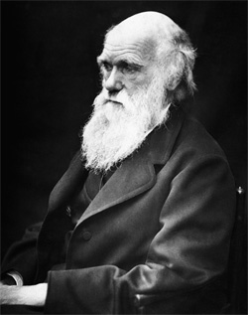An estimated 962 congregations across the United States and representing over a dozen countries are slated to participate in Evolution Weekend 2009 in honor of the evolutionary scientist, Charles’ Darwin. Others will mark the occasion over the course of the coming month in preaching and reflection.
The UCC Science and Technology Network recommends the accessible and nontechnical discussion, "Charles Darwin on Religion," by one of the world’s leading authorities on science and religion, John Hedley Brooke, a recent retiree from Oxford University.
The January 2009 issue of Smithsonian magazine has written a retrospective of Darwin on his 200th birthday. The article also contains a comparison of Darwin as an abolitionist and Abraham Lincoln, both born on the same day.
Worship resources, with litanies by the UCC biologist, Dr. Olivia White in conjunction with worship resource author Rev. Susan Blain, are found at <ucc.org/not-mutually-exclusive/pdfs/prayers.pdf>. New Century Hymnal suggestions for Evolution Weekend are available at <ucc.org/not-mutually-exclusive/pdfs/lectaids.pdf>.

